**Attendants :** Tony, Océane, Christine, Iman, Carlotta, Maelle, Graziela, Elliot.

**Mentioned topics :**

* Survey results (Elliot)
* INSERM pilot study (Christine)
* Discussion on workgroups to create
* General organization
* Next objectives

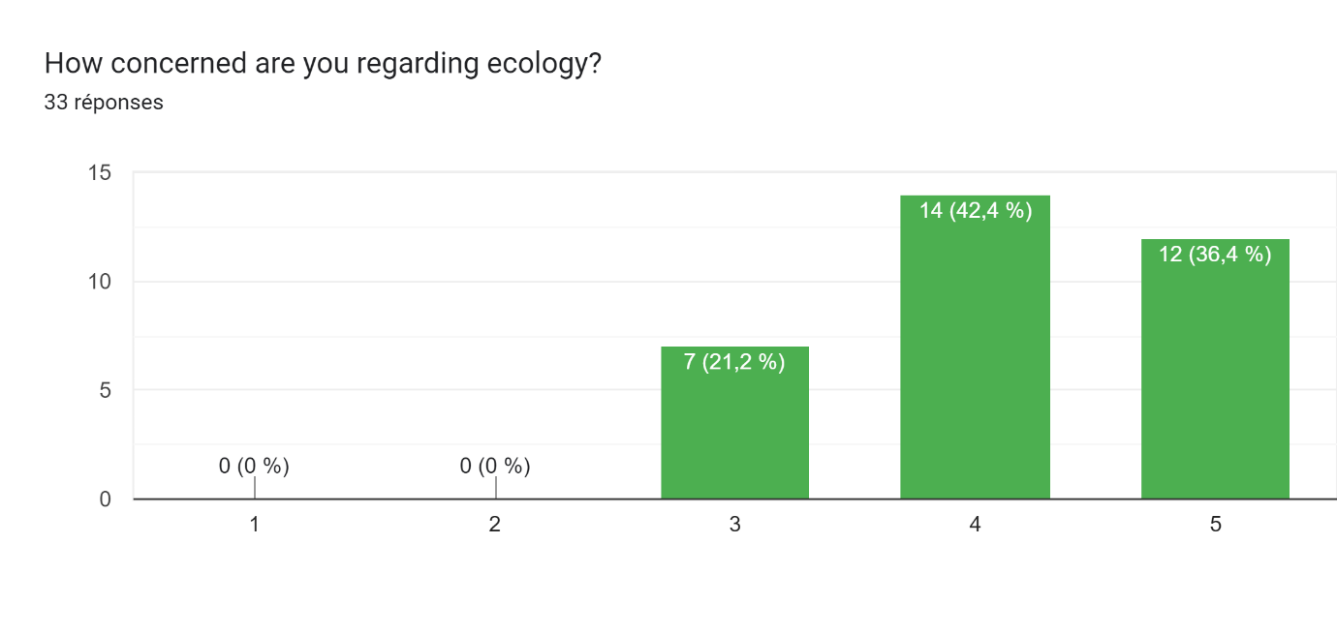**SURVEY RESULTS**

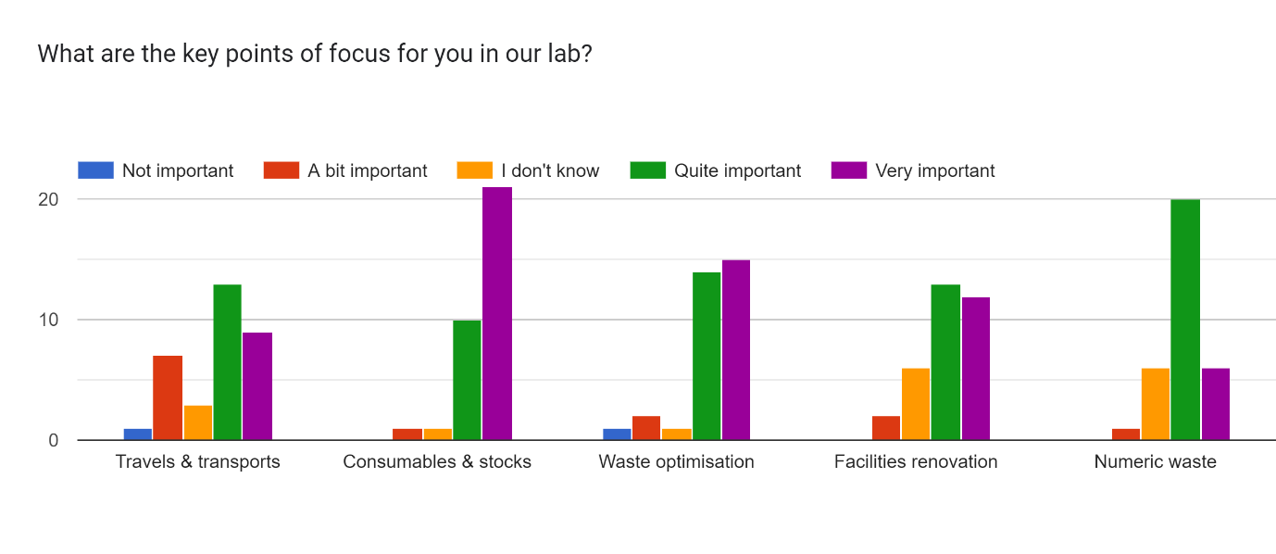People are globally very concerned about ecology in the lab, with 36% out of 33 persons that said to be very concerned, 42% quite concerned, and the remaining 21% that said to be concerned. Out of these 33 persons, 16 agreed to take part, and 17 declined, of which 11 wanted to be informed of the progresses of the initiative. Finally, here are the results of everyone regarding the topics that they think are the most important in the lab.

**INSERM PILOT STUDY**

Then, we discussed about the workshop we did for the INSERM pilot study, we had not received the results yet, it was supposed to be on June 14th, 2024. Budget for INSERM have been voted, and we are supposed to be contacted again to get more personalized feedback for our unit. We also asked them to have to pictures of the brainstorming sheets of paper that we did.

**WORKGROUPS**

Then, we discussed about the different workgroups to create. Here are those that we consider important so far, but you are welcome to ask for another one if you have ideas:

* Communication & training (Tony, Iman, Elliot…
* Transports (Maelle…
* Carbon Footprint of the Lab (Christine…
* Numeric waste (Graciela…
* Consumables and waste (Oceane, Carlotta, Christine…

Then, we went into the details of what is to do with each workgroup. We tried not to be ambitious; the idea is to start things without being too annoying for your daily lives. We all agreed on the fact that the carbon footprint is key to know which action is to take first, as well as sensibilizing people in the unit with small workshops, indicative panels…

Communication & Training

* Workshops “2tonnes” and “Fresque du Climat” organized at the INSERM scale, Carlotta and Elliot are now qualified to organize “2tonnes” on their own, we might organize one in the lab one day. These are two very informative workshops that you are all advised to follow (around 3-4h each). Several sessions are organized by your employer, by Paris cityhalls, by the “Académie du Climat de Paris”, by associations… If you are interested to know more, contact Elliot.
* On a similar note, you can try to estimate your own carbon footprint, which can give you ideas of what are the most important points of focus if you want to change things. Several websites can be used for that (ADEME…)
* Workshops are going to be organized regularly to sensibilize people about these topics and explain magnitudes or ideas of small things to implement. The first one is probably going to be on waste management in the lab.

Transports

As part of the global lab carbon footprint, a survey will be organized by Maelle to know how transportation is used in the lab, both for daily travels but also for missions and conferences.

* Daily 2023 work-home travels statistics: car, bike, public transportation.
* Mission orders + survey for travels in 2023: how much and where?

Carbon Footprint

Christine will contact Khadija to organize themselves, the biggest part for now is the consumables and orders. They will extract data from SAPHIRE and see if they need help to analyze the data, also with Césarine, Bibi…

For electricity consumption, Christine has recovered data from the hospital.

For the travels, the “Transport” group is working on it.

Elliot will ask his other unit in Institut Curie that has already started their carbon footprint ass well for information.

The analyze is made using the platform “GES1.5” developed by Labo1.5 (you can check their website, plenty of resources to inform yourself and quantitative data to help labs building a more sustainable research).

Numeric waste

Now action for now. Graciela and others have been formed as teachers in USPN, probably a lot of interesting things to use here as well.

Maybe some sensibilization to do amongst people of the lab for emails sorting, not sending emails all the time if you can discuss with people directly…

Maybe try to avoid signatures at the end of each email? But not sure this is a real influence, need quantitative data to know.

Consumables & waste

First action that we can do quickly: paper/cardboard will be separated from regular black bins. On top of that, formations on how to sort waste efficiently needs to be done again in the lab for everyone according to Christine. With the communication team, panels explaining where to trash what will be realized and new bins for paper will be added.

We must contact the hospital to ask them to start sorting paper. See if some of them are already active on this topic.

We will also have to think on how to reduce quantities of plastic we use during experiments, or use more glass instead of plastic, but this is hard, and we don’t have people in charge of cleaning glassware anymore.

We have to centralize all the orders where they send a huge box for a small tube, or twice dry ice for the same order… so that then we can ask them to do efforts and compare furnishers. Create this “green-contact-orders” with an email diffusion list as well.

**GENERAL ORGANIZATION**

No specific email address for the Green Initiative but Tony will create lists using our inserm addresses.

A space on the intranet will be created to put all the resources so that everyone can access them, including the meetings minutes.

We try to organize one global meetings every two months. Next one will be in September.

A whatsapp group will be created for people to discuss. Elliot is in charge.

**CONCLUSION OF THE DISCUSSIONS**

* We need the carbon footprint to know where to focus our actions first (consumables will be the highest, and transports probably the second).
* Organize a huge cleaning of the -80°C and -150°C fridges, probably a lot can be trashed to save some space. Maybe bring the freezers to -70°C, and “unfreezing” must be performed from time to time.
* For September, we will try to organize a sensibilization session for everyone.
* We will prepare a small chart of the gestures easy to do, “small green gestures” like using the stairs instead of the lift automatically, switch everything off before leaving including computers screen and power, …

**HOW TO JOIN?**

If you want to help and bring your contribution, you are more than welcome even if you don’t have much time to give! Also, if you have suggestions do not hesitate. We will create diffusion lists, but for now you can contact any person from the Green Initiative. The meetings are for everyone, we will communicate the precise date for the next meeting, here is a doodle to determine it.