Attendants : Tony, Océane, Christine, Carlotta, Maëlle, Murielle, Virginie, Hichem, Elliot.
Mentioned topics :
- Pilot study (Christine)
- Workgroups created and action for each group (Elliot)
- Workshop 2Tonnes (Elliot)
- Data availability
- Next meeting, whatsapp group, and discussion

PILOT STUDY
Christine has a meeting this afternoon (19/09/24) to discuss with Matthieu and others of INSERM. Nothing to add.
WORKGROUPS
- Carbon footprint
Khadija is off for now on consumables. Christine will try to see whether she can bypass. The guy from INSERM must have the data, as well as filters to get only orders from our unit. Then, Elliot’s other lab has setup a GitHub code with AI to automatically assign a NACRES code to every product of a list, and compute the associated carbon cost. Try to take it.
Data of electricity consumption are already available. For transports, Maelle is on it.
Idea on the impact of DASRI burning? Sensitize people about it maybe.
- Communication
Workshop 2 Tonnes (described hereafter). Set up for trainings of HSE focusing on trash: new PhD and interns to come mostly in January, will be done by Christine + visuals to prepare (Carlotta&Océane). Can also do internal trainings with at least one person of each teams.
Starlab tips boxes for mini-gardening→ we don’t do, not interesting.
Ideas boxes to help people participate. Anonymous or not. Can be put in corridor 1st floor.
Small presentation at next seminar, contact Marie for that.
- Numeric waste
No concrete action yet.
Graziela mentioned removing signatures last time, does it have an impact?
Sensitize ppl by making signs to switch off machines, computers, lights, hoods… But before that, Tony mentioned it would be important to quantify the impact of the action. So first, we’ll count what is still switched on at night (ppl that leaves the lab super late will do it).
- Consumables
First action has been done, to add paper bins. But we need to give it more visibility by telling people and making signs. In Villetaneuse, ppl were motivated at first but then slowly stopped doing efforts, we’ll have to motivate them again.
Contact hospital for the sorting of paper and cardboard. Christine knows the responsible for logistics, she will give the contact.
Bins for piles to setup, easy and cheap. One at the entrance, maybe we don’t need in every offices. They have this in Villetaneuse already. Christine takes care of that.
Project of orders centralization: standby for now, not relevant at the scale of our lab, and asks for much energy for not a lot of results at the scale of the hospital, maybe wait the fusion with the Cri in St Ouen. In the lab we already have the consumables and histology solvents in common, for the rest it’s complicated to know which funds will pay if we start adding more materials to the common list.
Reuse plastic: first put ppl in a “green” mood and then ask them to do efforts in their experiments. Example of gloves in culture rooms. We discussed it together (globally it’s said you should not wear gloves in cell culture unless for a specific reason) but it would be nice to trigger this discussion at the scale of the lab. Launch a meeting with Teresa, Angelique, Charles and Stephane, and Christine and motivated users, on good practices in culture.
At 3rd floor, they have added the price of medium bottles, why not doing the same with gloves and tips, and adding the carbon footprint if possible. And paper rolls as well.
- Transports
Survey to be done by Maelle, Elliot will give her some data from his other lab with an already ready survey.
To get conferences travels, mission orders can be asked to the secretary.
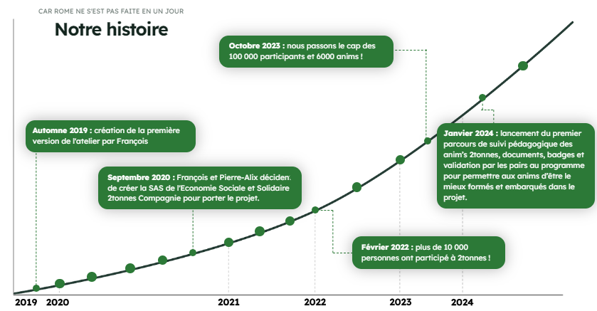
2TONNES WORKSHOP
Thursday 3rd October, afternoon, 2-6pm.
Structure is already well setup, existing since 2010 (erratum: 2019)
Last 3h30-4h, for up to 15 people.
Personal carbon footprint, for an average French it’s 9-11 tons. Why do we speak about “2 tons” ? Paris agreements aims at less than 1.5°C increase in average temperature, which gives 2 tones per capita before 2050 if you convert in terms of nbr of people on Earth.
The workshop is an immersive game where people are either themselves or ministers depending on the round, and take decisions to decrease their carbon footprint, as well as policies to help inhabitants in this process. Gives many ideas, magnitudes, and pieces of knowledge to decrease one’s carbon footprint, usually motivating for people to act afterwards.
Elliot has put posters in the lab and sent it by email.
GENERAL ORGANIZATION
Green Initiative has been added to the website, in “spotlights”. You can find minutes from every meeting, as well as a seminar advertised by Raphael Levy.
Objectives next meeting:
- Next seminar, mention Green Initiative (Elliot)
- Workshop “trash” (Christine)
- Ideas box corridor
- Signs bins (Christine + Océane + Elliot)
- Count machines switched on at night (Maelle + Elliot morning/Carlotta + Hichem + Océane night → next week).
- Contac logistic responsible hospital (Christine + Elliot).
- Green Initiative intervention regularly this year (other people than Elliot to change)
- Survey transportation (Maelle)
- Piles collector (Christine) + old cables?
- Meeting cell culture on good practices (Elliot)
- Posters with prices of gloves, mediums, tips…
CONCLUSION OF THE DISCUSSIONS
- Next meeting is Friday, 22nd November 2024 at 10 am in meeting room, Bichat.
- Whatsapp group and community to join if wanted, ask Elliot, Hichem, Océane…
HOW TO JOIN?
If you want to help and bring your contribution, you are more than welcome even if you don’t have much time to give! Also, if you have suggestions do not hesitate, especially when the “Ideas box” will be ready. The meetings are for everyone, the next one being on Friday, 22nd November. Contact any person from the initiative OR greeninitiatives.u1148@inserm.fr if needed.

